**Assignment No.3**

| **NAME: Atharva R Thakur** | **CLASS: AI&DS-C** |
| --- | --- |
| **ROLL NO: 43** | **PRN: 12110833** |

**Assignment No.3**

**Title**

Find a procedure to transfer the files from one virtual machine to another virtual machine

**Steps**

a. Download and install Oracle's Virtual Box

https://www.virtualbox.org/wiki/Downloads

b. Download Ubuntu VMDK Image

https://app.vagrantup.com/bento/boxes/ubuntu-18.04

c. Launch Virtualbox and create a new VM

d. Click on new and mention the Name and the machine folder along with the Type and Version of the Machine to be created.

e. Assign memory size for our VM (1024 MB sufficient for now).

f. Select the option *Use an existing virtual hard disk file* and locate the downloaded VMDK image and create VM

g. Now we have to create a NAT Network so go to *File -> Preferences -> Network -> Add a New NAT Network (Click on +)*

h. Right click and edit the Network name and CIDR if needed.

i. Repeat the process of launching the VM for 2 instances

j. Now go to the setting, go to the network setting and change the adapter to NAT Network and select the NAT Network you made

k. Launch the VM now

l. Install the net-tools to know the IP's of the instance

m. create a file and write something into it

n. If your file is on the VM with IP **172.168.2.4** and the second VM's IP is **172.168.2.5**.

o. Transfer the file using **SCP**

p. $ scp tranfer.txt vagrant@172.168.2.5:/home/vagrant

q. Check for the file in the Second VM under the **/home/vagrant** directory **Video Link**

https://www.youtube.com/watch?v=0MaS0nZCTZc

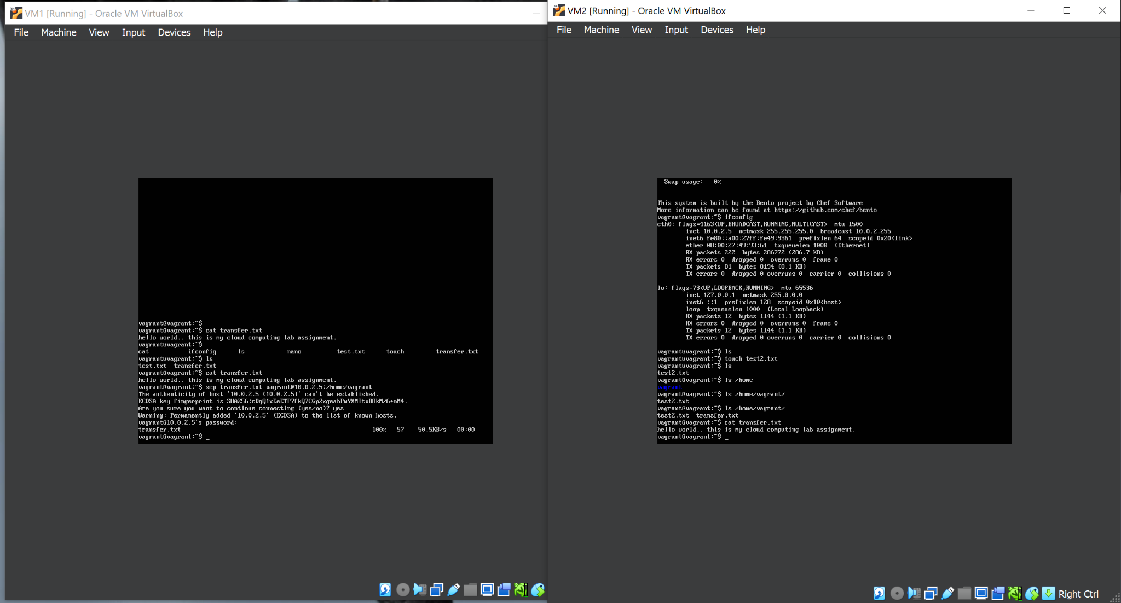

VM1

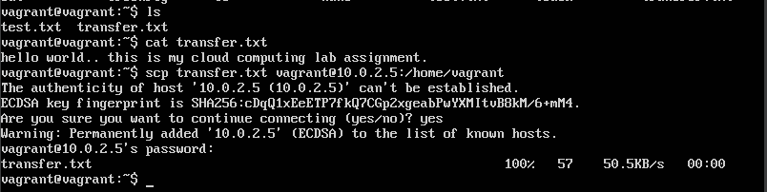

VM2

